**bulletin crossbulletin cross**

**REDEEMER LUTHERAN CHURCH**

##### 320 WEST CENTRAL AVENUE

###### ARKANSAS CITY, KS 67005-2637

[**www.rlcarkcity.com**](http://www.rlcarkcity.com)

A congregation of the Lutheran Church Missouri Synod – lcms.org

Adopted mission: West Africa – Pastor Tim and Beth Heiney

Dominican Republic –– Pastor Daniel and Kathy Conrad

**Church Office - 620-442-5240** [**secretaryrlc320@gmail.com**](mailto:secretaryrlc320@gmail.com)

**Pastor Christopher Warneke 402-705-1709**

**pastorcwarneke@gmail.com**



**LSB Divine Service Setting I**

**Fifteenth Sunday after Pentecost**

**September 1, 2024**

**Hymn of Invocation “God’s Own Child, I Gladly Say It” No. 594**

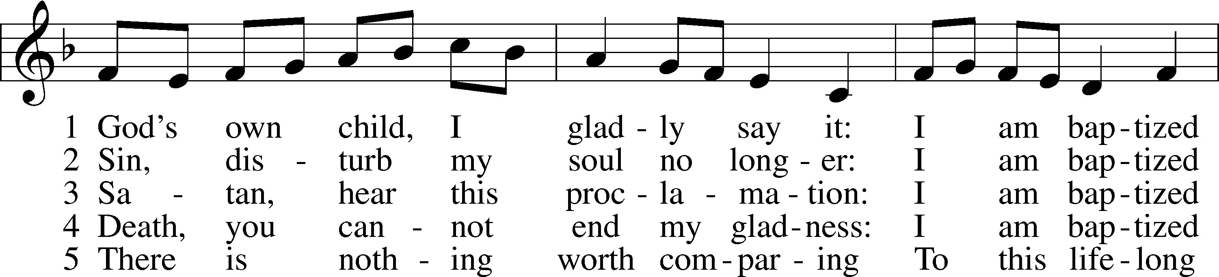

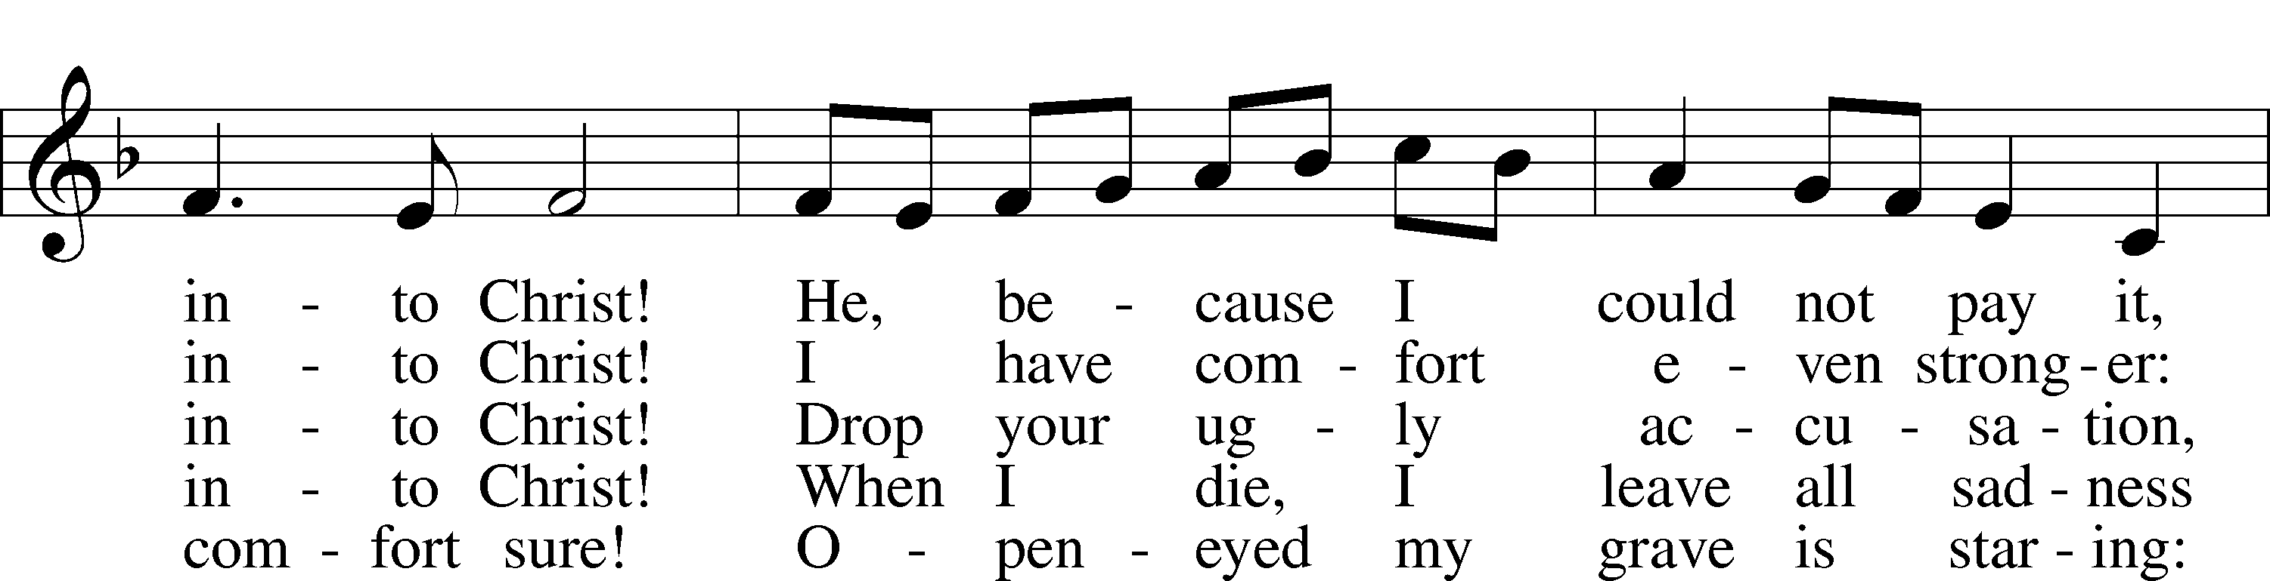

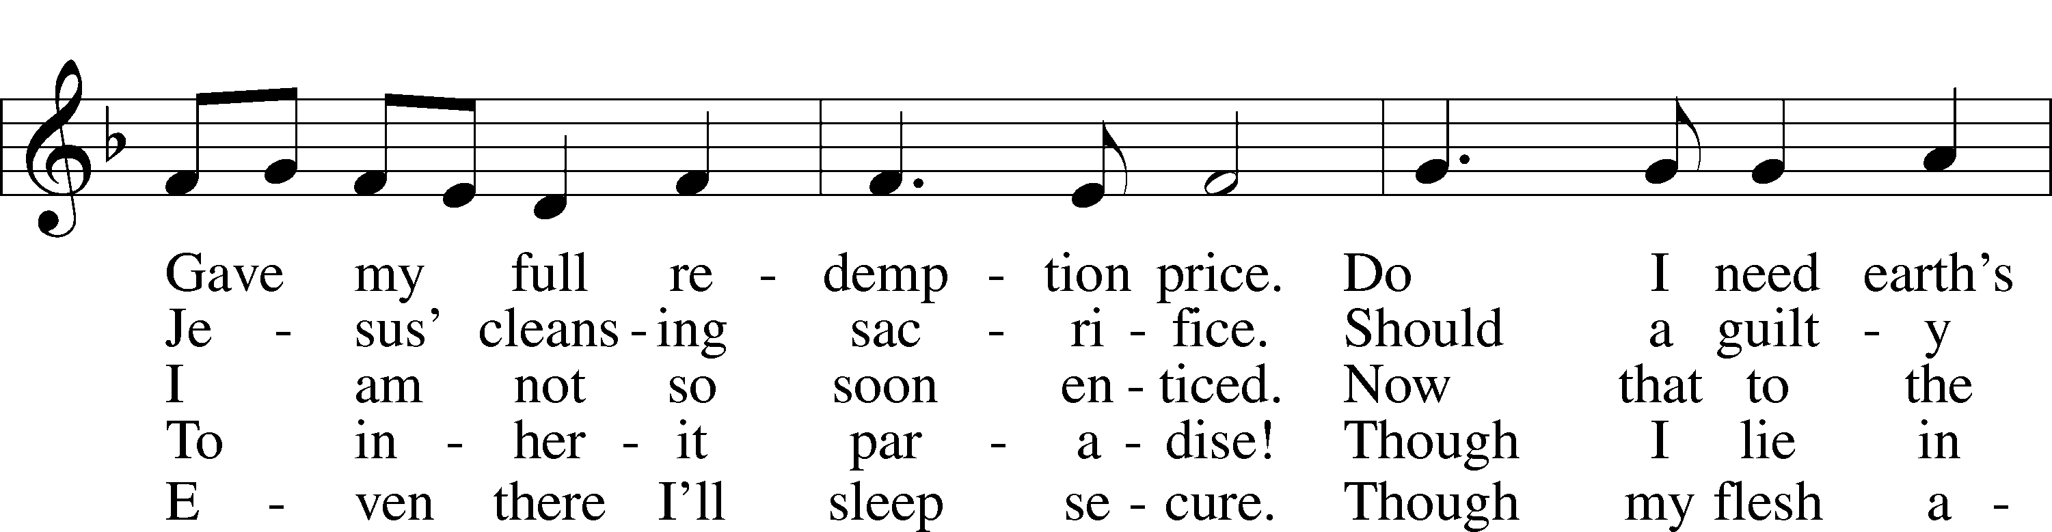

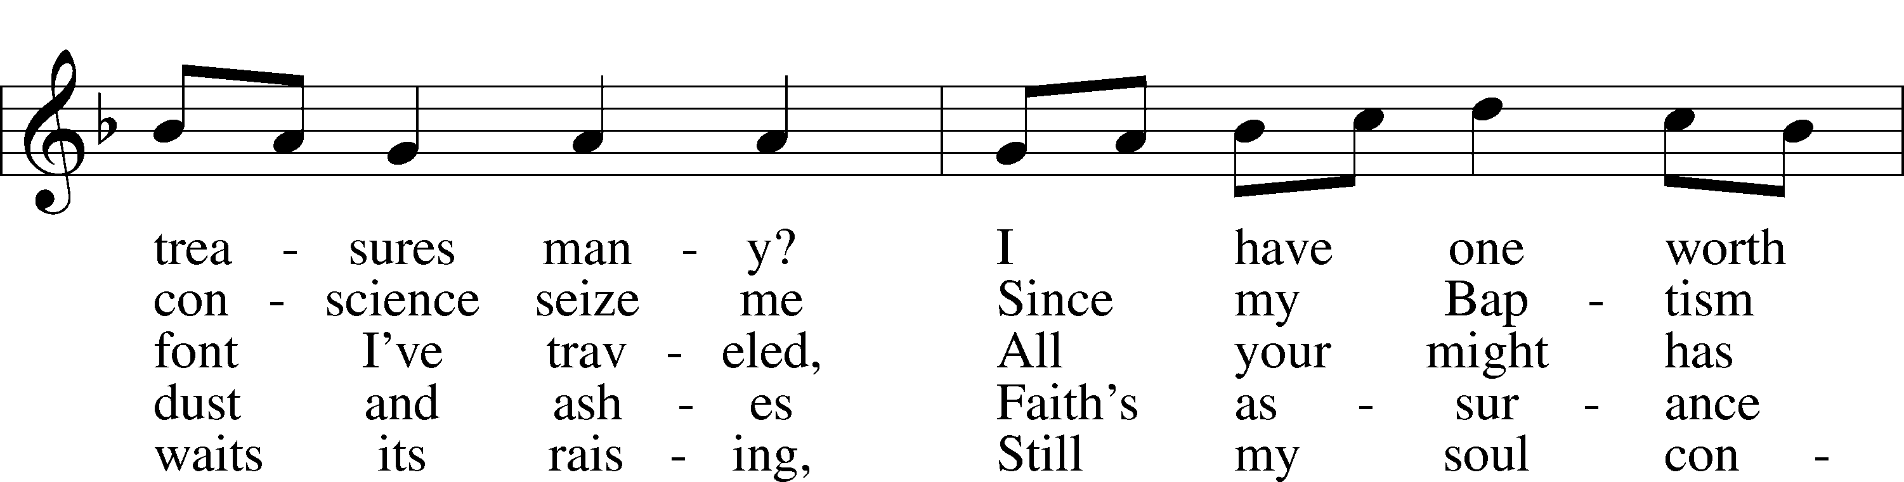

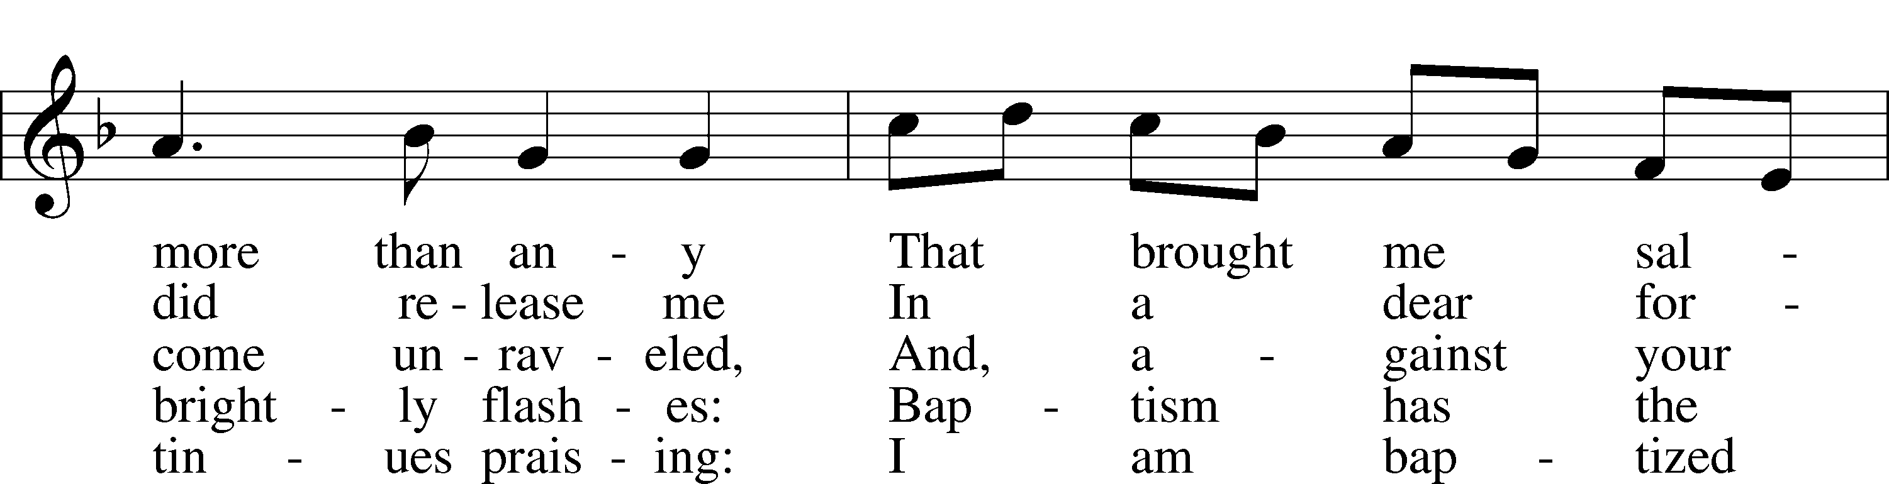

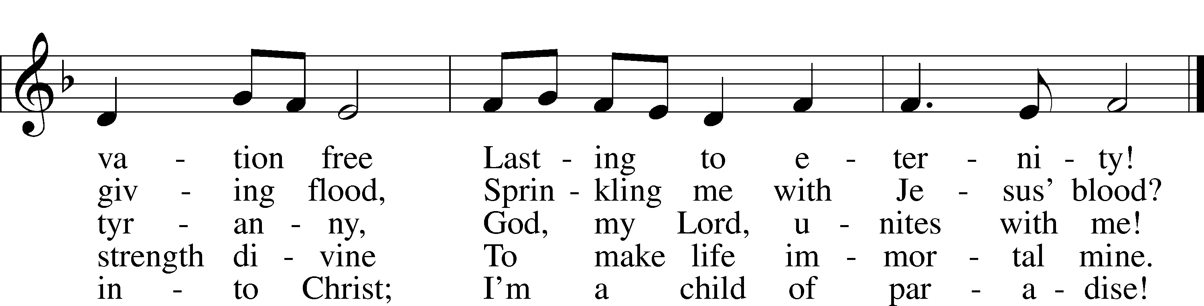

Text: Erdmann Neumeister, 1671–1756; tr. Robert E. Voelker, 1957 Tune: Johann Caspar Bachofen, 1695–1755, alt. Text: © 1991 Robert E. Voelker. Used by permission: LSB Hymn License no. 110002060 Tune: Public domain

*(stand)*

## Confession and Absolution

P: In the name of the Father and of the ✠ Son and of the Holy Spirit.

**C: Amen.** *Matthew 28:19 and 18:20*

P: If we say we have no sin, we deceive ourselves, and the truth is not in us.

**C: But if we confess our sins, God, who is faithful and just, will forgive our sins and cleanse us from all unrighteousness.**

*Silence for reflection on God's Word and for self-examination.*

P: Let us then confess our sins to God our Father.

**C: Most merciful God, we confess that we are by nature sinful and unclean. We have sinned against You in thought, word, and deed, by what we have done and by what we have left undone. We have not loved You with our whole heart; we have not loved our neighbors as ourselves. We justly deserve Your present and eternal punishment. For the sake of Your Son, Jesus Christ, have mercy on us. Forgive us, renew us, and lead us, so that we may delight in Your will and walk in Your ways to the glory of Your holy name. Amen.**

P: Almighty God in His mercy has given His Son to die for you and for His sake forgives you all your sins. As a called and ordained servant of Christ, and by His authority, I therefore forgive you all your sins in the name of the Father and of the ✠ Son and of the Holy Spirit.

**C: Amen.**  *I John 1:12 and Philippians 1:6*

**Introit** *Psalm 51:7, 10–12; antiphon: v. 2*

P: Wash me thoroughly from my iniquity,  
**C: and cleanse me from my sin!**

P: Purge me with hyssop, and I shall be clean;  
**C: wash me, and I shall be whiter than snow.**

P: Create in me a clean heart, O God,  
**C: and renew a right spirit within me.**

P: Cast me not away from your presence,  
**C: and take not your Holy Spirit from me.**

P: Restore to me the joy of your salvation,  
**C: and uphold me with a willing spirit.**

**All: Glory be to the Father and to the Son** **and to the Holy**

**Spirit; as it was in the beginning,** **is now, and will be forever.**

**Amen.**

P: Wash me thoroughly from my iniquity,  
**C: and cleanse me from my sin!**

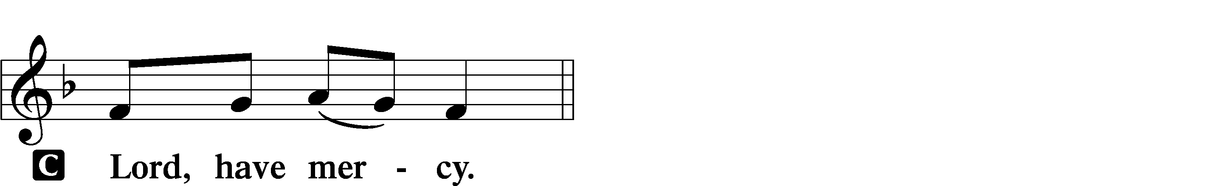**Lord Have Mercy (Kyrie)**Mark 10:47

P: In peace let us pray to the Lord

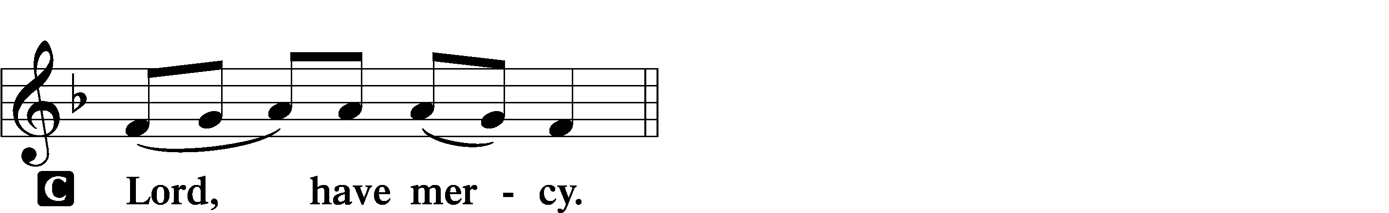

P: For the peace from above and for our salvation let us pray to the Lord.

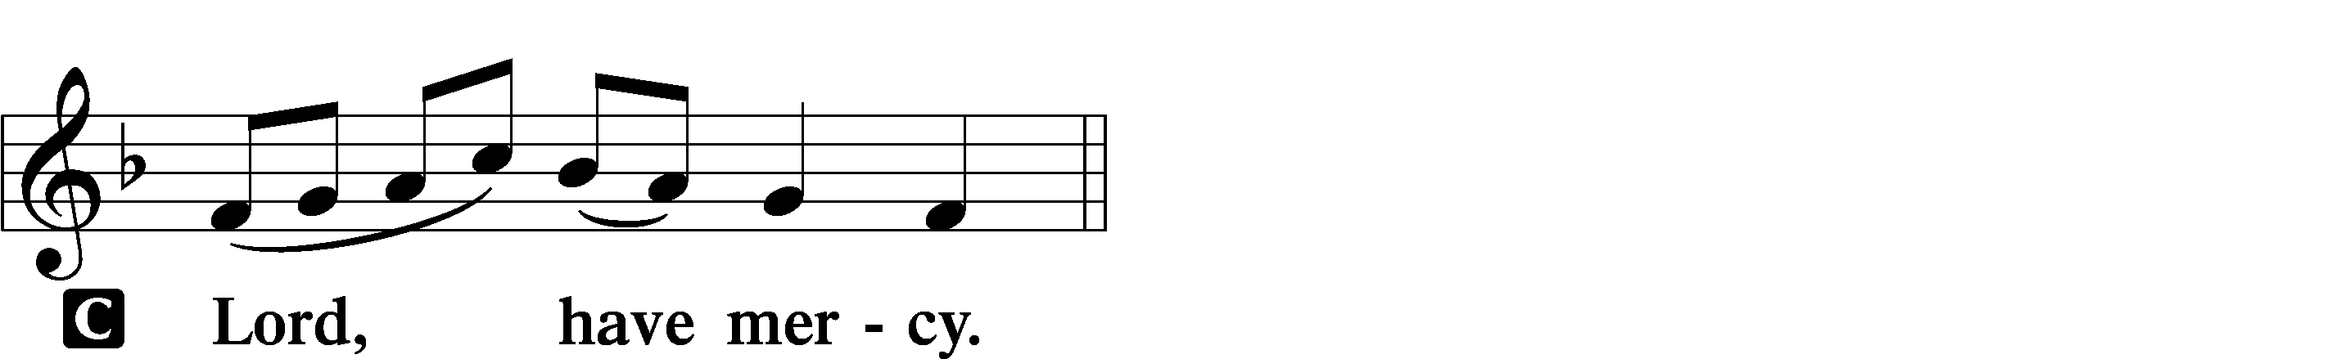P: For the peace of the whole world, for the well-being of the Church of God and for the unity of all let us pray to the Lord.

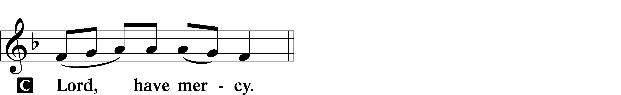

P: For this holy house and for all who offer here their worship and praise, let us pray to the Lord.



P: Help, save, comfort and defend us, gracious Lord.

**Glory to God in the Highest (Gloria in Excelsis)** *Romans 8:34*

P: Glory to God in the highest, and peace to His people on earth.

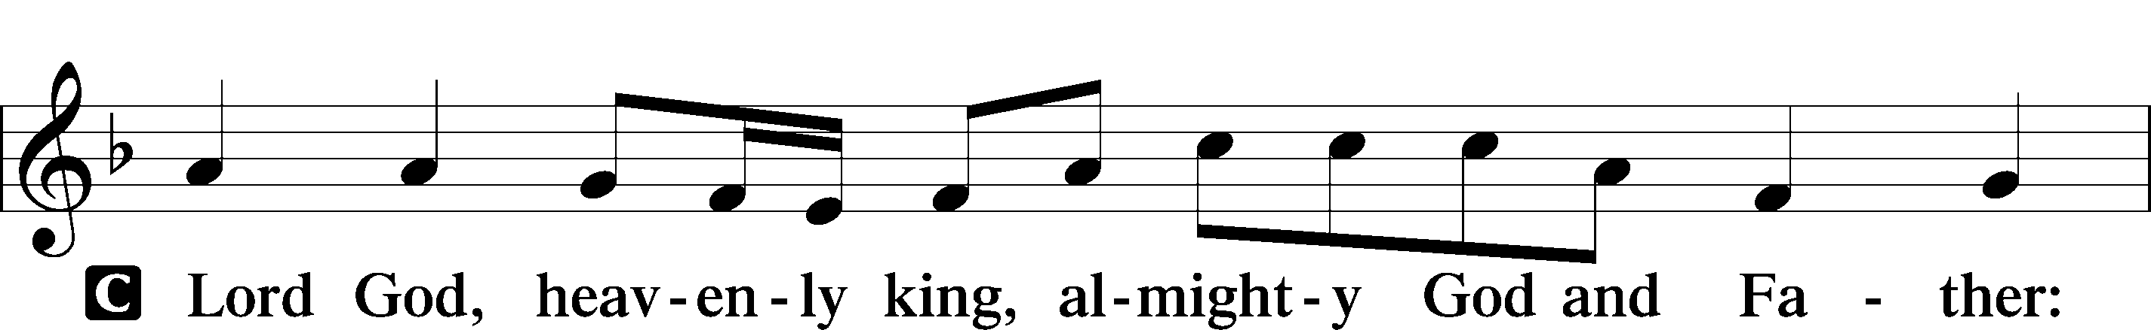

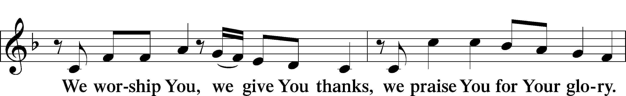

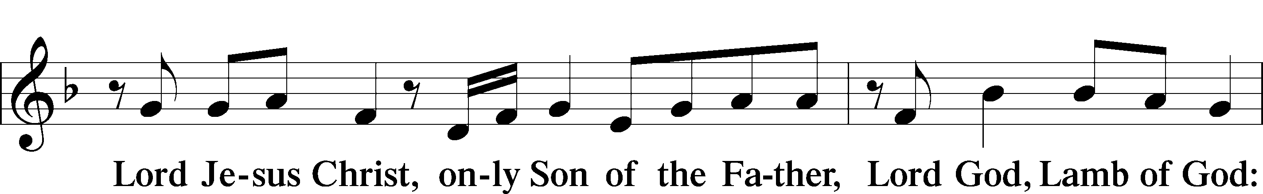

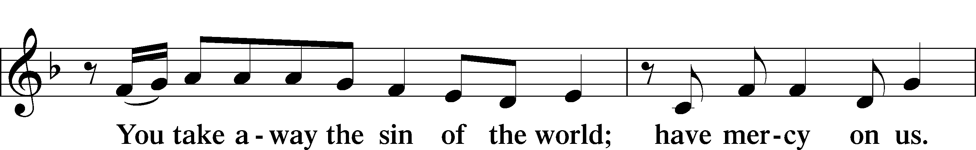

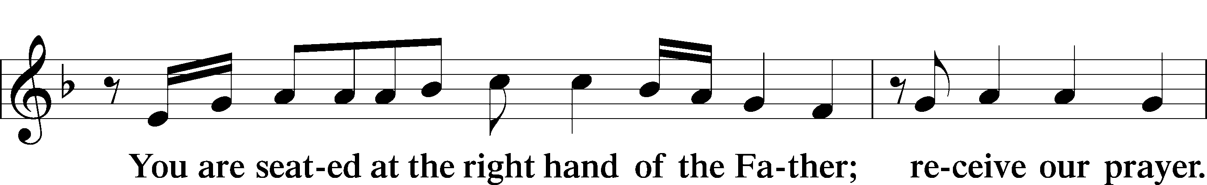

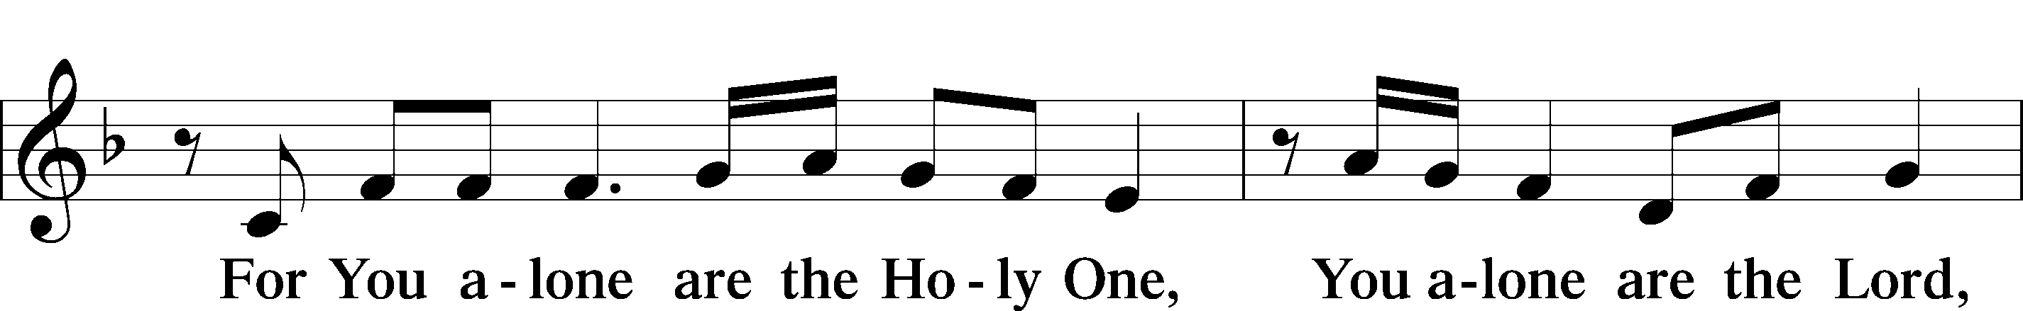

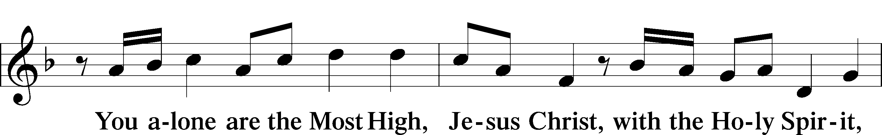

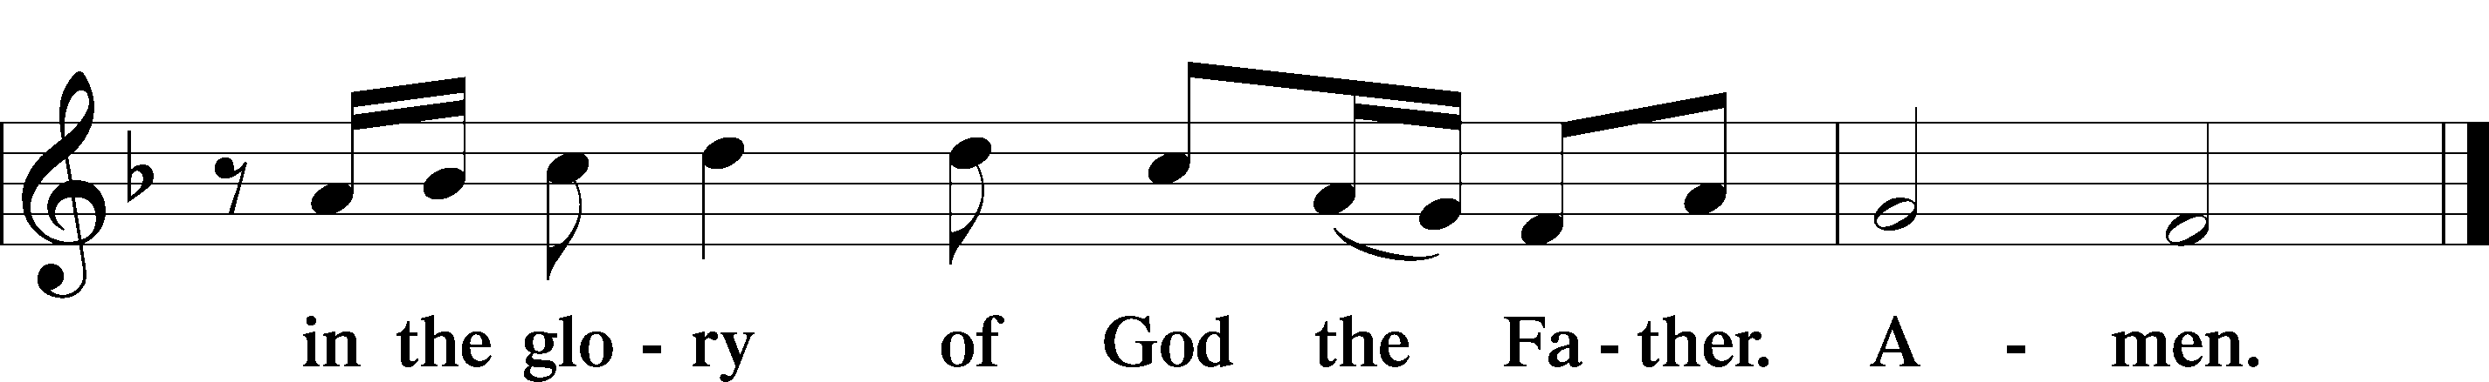

**Salutation and Collect**

P: The Lord be with you.

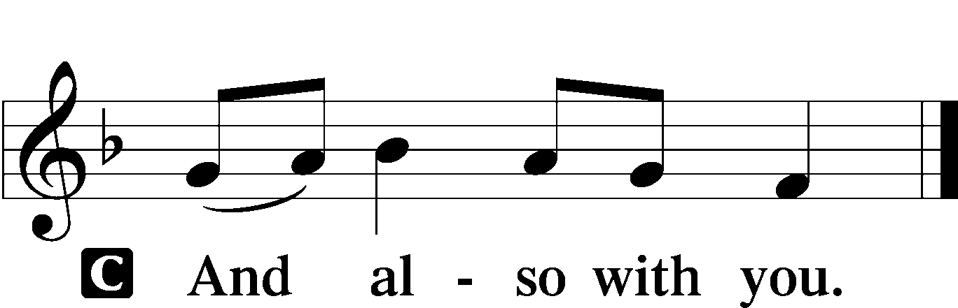

P: Let us pray… one God, now and forever.

**C: Amen.**

*(sit)*

**Old Testament Reading** *Deuteronomy 4:1–2, 6–9*

1“Now, O Israel, listen to the statutes and the just decrees that I am teaching you, and do them, that you may live, and go in and take possession of the land that the Lord, the God of your fathers, is giving you. 2You shall not add to the word that I command you, nor take from it, that you may keep the commandments of the Lord your God that I command you. . . .

6Keep them and do them, for that will be your wisdom and your understanding in the sight of the peoples, who, when they hear all these statutes, will say, ‘Surely this great nation is a wise and understanding people.’ 7For what great nation is there that has a god so near to it as the Lord our God is to us, whenever we call upon him? 8And what great nation is there, that has statutes and just decrees so righteous as all this law that I set before you today?

9“Only take care, and keep your soul diligently, lest you forget the things that your eyes have seen, and lest they depart from your heart all the days of your life. Make them known to your children and your children’s children.”

P: This is the Word of the Lord.

**C: Thanks be to God.**

**Memory Verse** *Romans 1:16*

**All: For I am not ashamed of the gospel, for it is the power of God for salvation to everyone who believes, to the Jew first and also to the Greek.**

**Epistle** *Ephesians 6:10–20*

10Finally, be strong in the Lord and in the strength of his might. 11Put on the whole armor of God, that you may be able to stand against the schemes of the devil. 12For we do not wrestle against flesh and blood, but against the rulers, against the authorities, against the cosmic powers over this present darkness, against the spiritual forces of evil in the heavenly places. 13Therefore take up the whole armor of God, that you may be able to withstand in the evil day, and having done all, to stand firm. 14Stand therefore, having fastened on the belt of truth, and having put on the breastplate of righteousness, 15and, as shoes for your feet, having put on the readiness given by the gospel of peace. 16In all circumstances take up the shield of faith, with which you can extinguish all the flaming darts of the evil one; 17and take the helmet of salvation, and the sword of the Spirit, which is the word of God, 18praying at all times in the Spirit, with all prayer and supplication. To that end keep alert with all perseverance, making supplication for all the saints, 19and also for me, that words may be given to me in opening my mouth boldly to proclaim the mystery of the gospel, 20for which I am an ambassador in chains, that I may declare it boldly, as I ought to speak.

P: This is the Word of the Lord.

**C: Thanks be to God.**

*(stand)*

**Alleluia and Verse** *John 6:68*

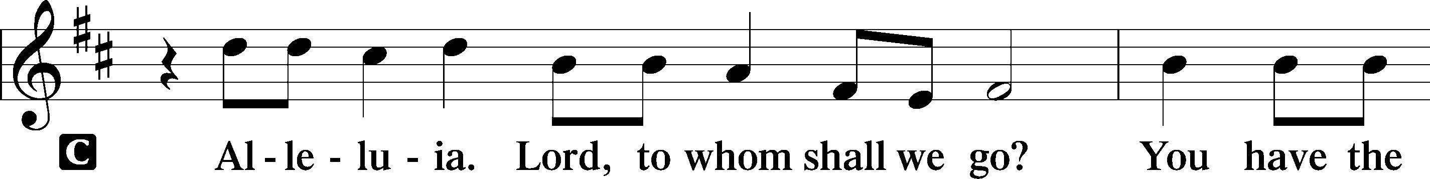

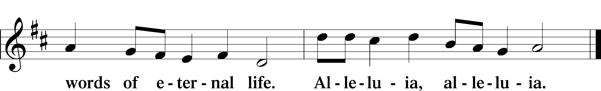

**Holy Gospel** *Mark 7:14-23*

P: The Holy Gospel according to St. Mark, the seventh chapter.

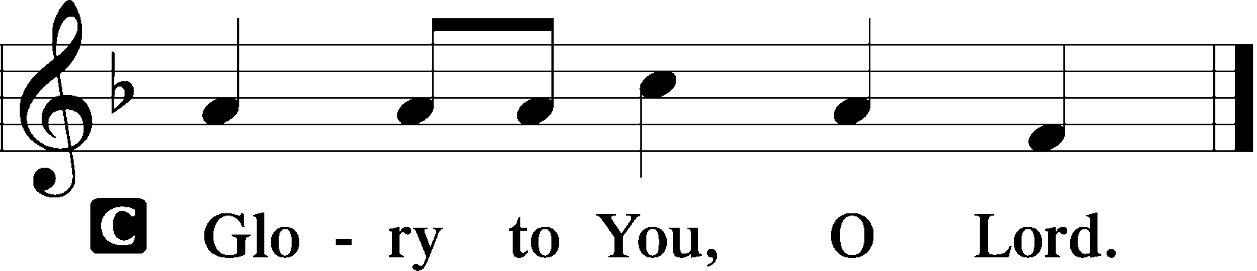

14[Jesus] called the people to him again and said to them, “Hear me, all of you, and understand: 15There is nothing outside a person that by going into him can defile him, but the things that come out of a person are what defile him.” 17And when he had entered the house and left the people, his disciples asked him about the parable. 18And he said to them, “Then are you also without understanding? Do you not see that whatever goes into a person from outside cannot defile him, 19since it enters not his heart but his stomach, and is expelled?” (Thus he declared all foods clean.) 20And he said, “What comes out of a person is what defiles him. 21For from within, out of the heart of man, come evil thoughts, sexual immorality, theft, murder, adultery, 22coveting, wickedness, deceit, sensuality, envy, slander, pride, foolishness. 23All these evil things come from within, and they defile a person.”

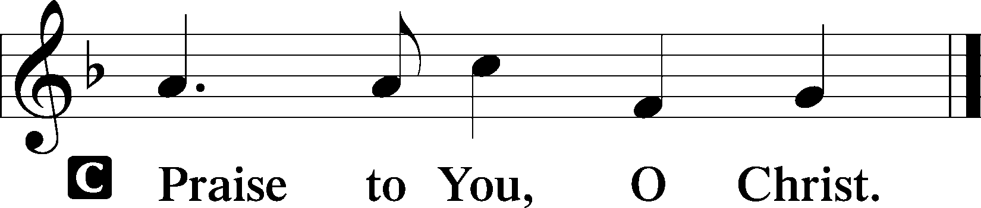P: This is the Gospel of the Lord.

*(Sit)*

Hymn of the Day “By Grace I’m Saved” No. 566

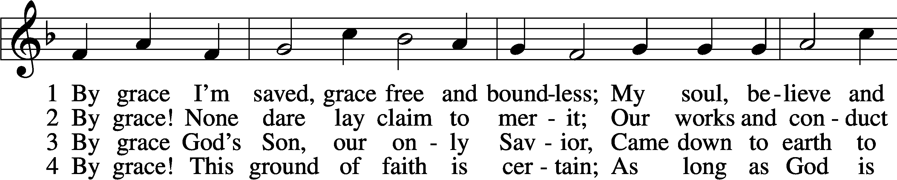

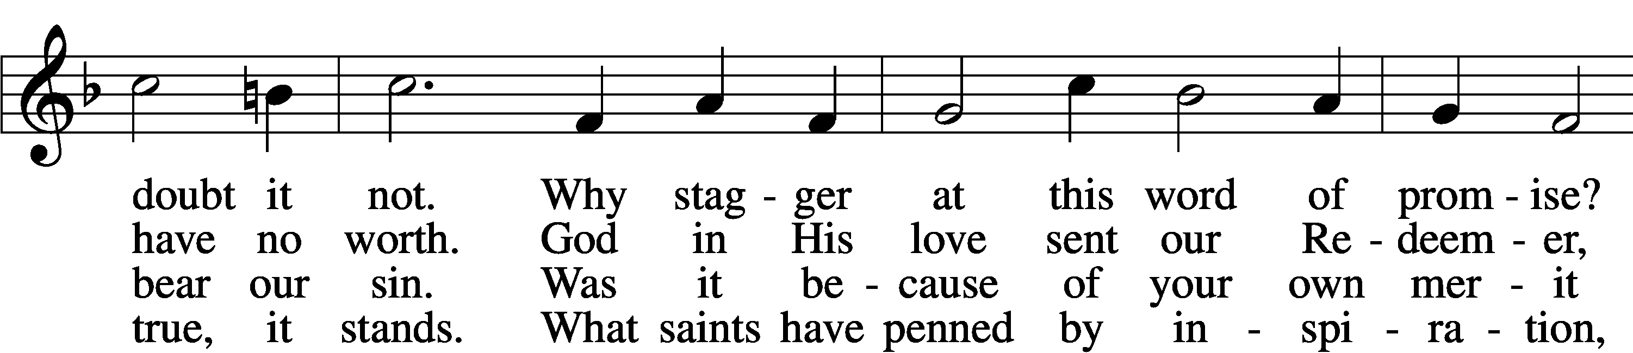

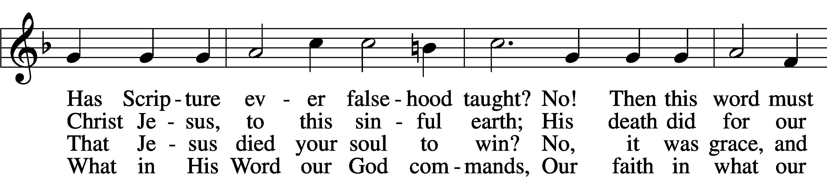

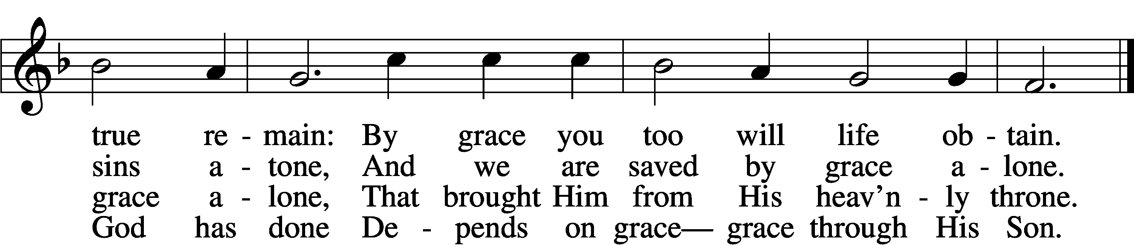

5 By grace to timid hearts that tremble,  
    In tribulation’s furnace tried,  
By grace, in spite of fear and trouble,  
    The Father’s heart is open wide.  
Where could I help and strength secure  
If grace were not my anchor sure?

6 By grace! On this I’ll rest when dying;  
    In Jesus’ promise I rejoice;  
For though I know my heart’s condition,  
    I also know my Savior’s voice.  
My heart is glad, all grief has flown

Since I am saved by grace alone. Text: Christian Ludwig Scheidt, 1709–61; tr. The Lutheran Hymnal, 1941, alt. Tune: Cornelius Heinrich Dretzel, 1697–1775 Text and tune: Public domain

Sermon

*(stand)*

**The Apostles’ Creed**

**I believe in God, the Father Almighty, maker of heaven and earth.**

**And in Jesus Christ, His only Son, our Lord, who was conceived by the Holy Spirit, born of the virgin Mary, suffered under Pontius Pilate, was crucified, died and was buried. He descended into hell. The third day He rose again from the dead. He ascended into heaven and sits at the right hand of God the Father Almighty. From thence He will come to judge the living and the dead.**

**I believe in the Holy Spirit, the holy Christian Church, the communion of saints, the forgiveness of sins, the resurrection of the body, and the life everlasting. Amen.**

**Prayer of the Church -** *After each petition*

P: Lord, in your mercy, C: hear our prayer.

*(sit)*

Offering

*(stand)*

**Offertory**

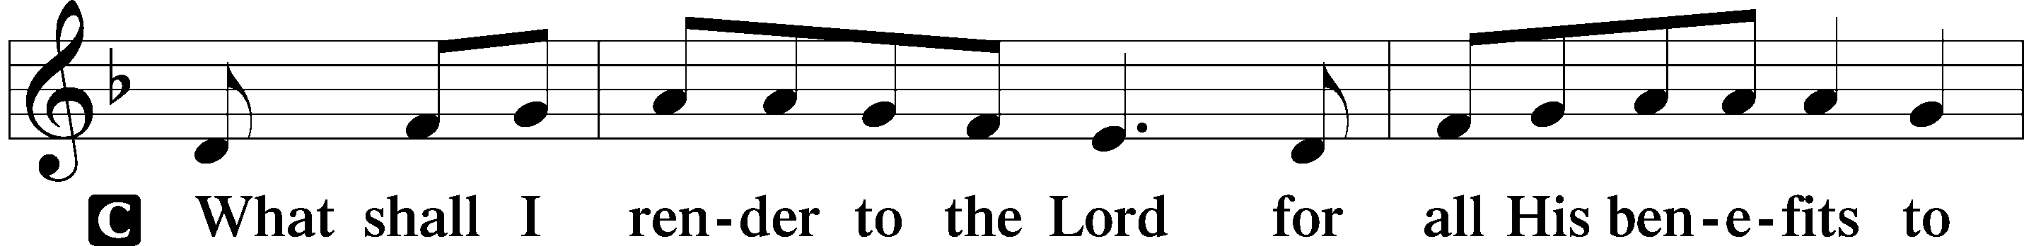

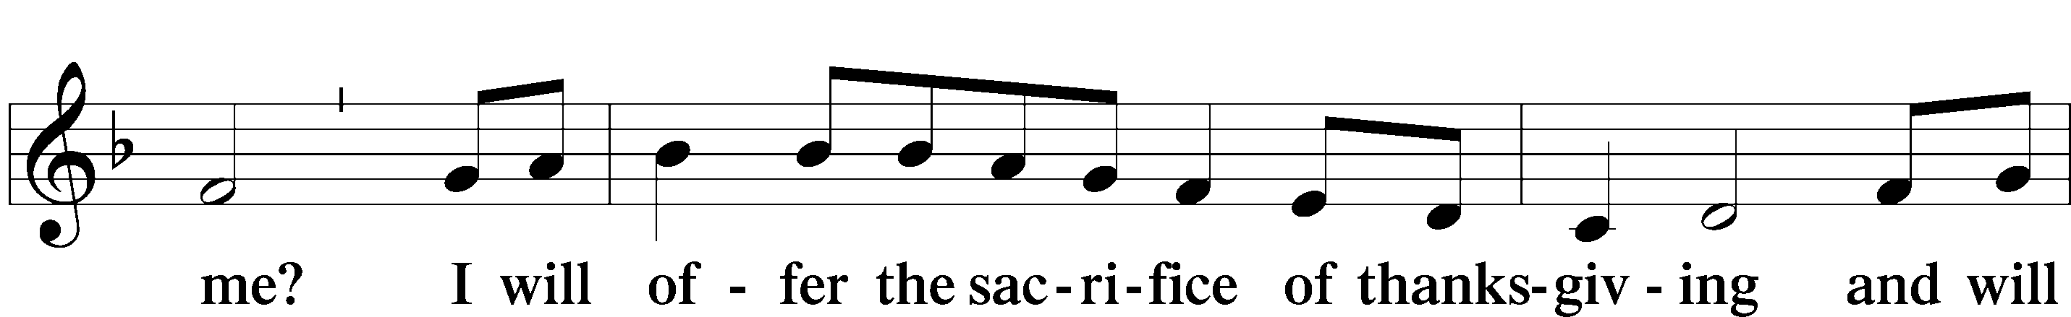

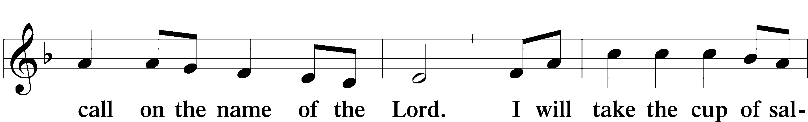

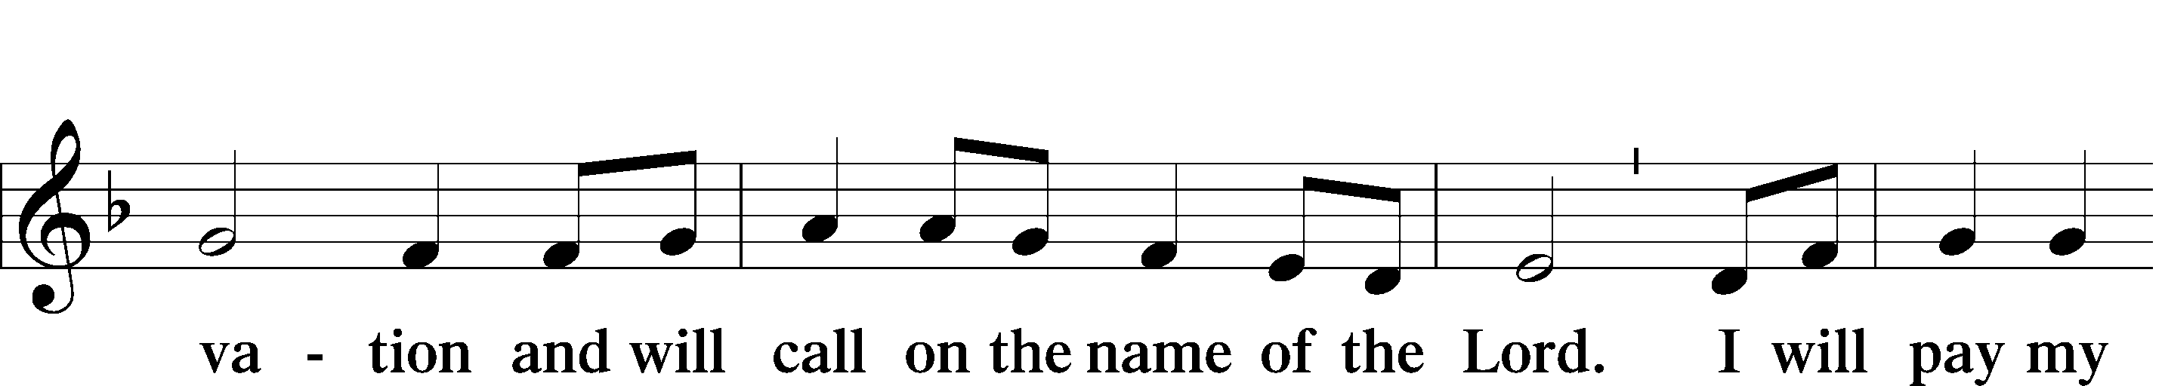

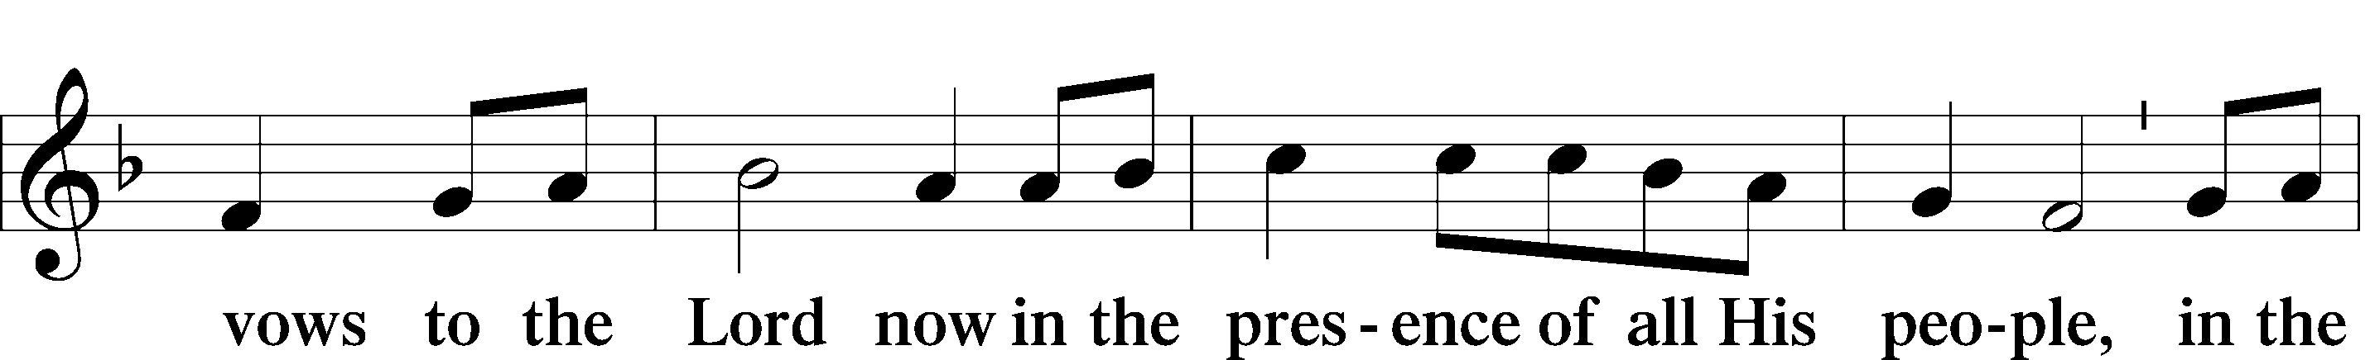

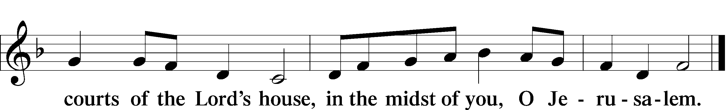

**The Lord’s Prayer***Matthew 6:9-13*

**Our Father, who art in heaven, hallowed be Thy name. Thy kingdom come. Thy will be done on earth as it is in heaven. Give us this day our daily bread, and forgive us our trespasses as we forgive those who trespass against us. And lead us not into temptation, but deliver us from evil. For thine is the kingdom and the power and the glory forever and ever. Amen.**

**Concluding Collect**

**The Benediction** *Numbers 6:24-26*

P: The Lord bless you and keep you. The Lord make His face shine on you And be gracious to you. The Lord look upon you with favor and give you peace.

**C: Amen.**

*(Sit)*

Closing Hymn “Not What These Hands Have Done” No. 567

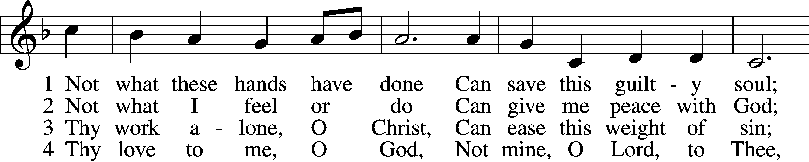

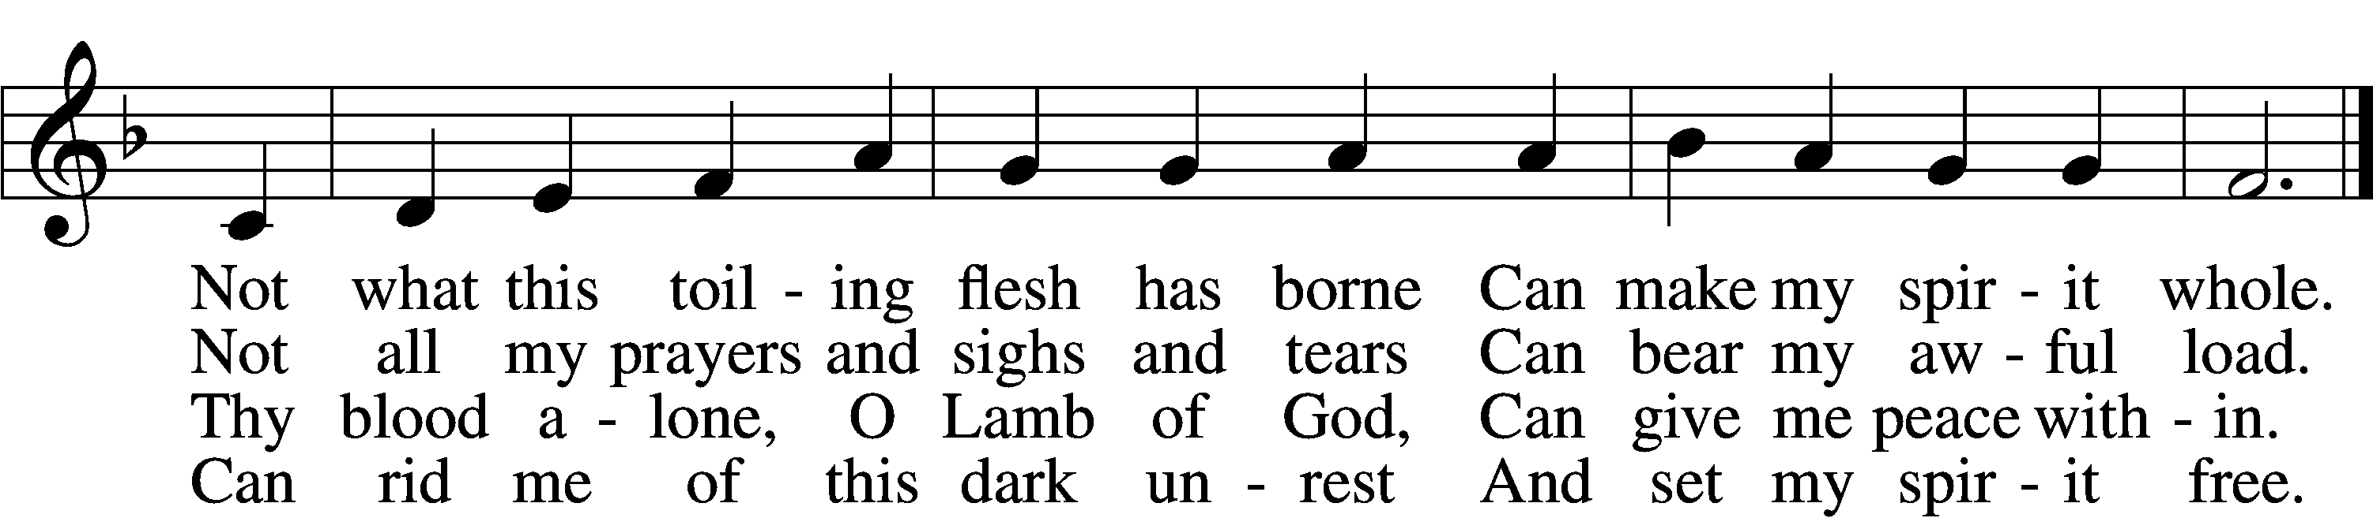

5 Thy grace alone, O God,  
    To me can pardon speak;  
Thy pow’r alone, O Son of God,  
    Can this sore bondage break.

6 I bless the Christ of God,  
    I rest on love divine,  
And with unfalt’ring lip and heart  
    I call this Savior mine.

Text: Horatius Bonar, 1808–89 Tune: William H. Monk, 1823–89 Text and tune: Public domain

**✞ ✞ ✞**

* **THE ALTAR FLOWERS** are given to the glory of God by Pattie & Duane Oestmann in honor of their Grandchildren & Great Grandchildren.
* **IN OUR PRAYERS** we remember all who are ill or under medical care, Marty Villars, Barbara Elliott, Deanna Hegedus, Diana Trent, Barb Sweet, Randy Sweet, Sue Krueger, Marcie Wellday, Dana Anderson, Janet Shrewsberry, Tyler Voegele, Clara Hays.



Confirmation Classes will begin at 6:00 pm on Wednesday, September 11th with a meeting of parents and students. The goals and expectations of Confirmation Class will be explained.



Youth Group will meet on the Wednesday, September 11th at 7:00 pm.

All 5th through 12th graders are welcome.

**Come join us** for our interesting and exciting Bible study of “Job” at 9:00 am in adult Sunday School.

# FRIDAY, SEPTEMBER 13 starting at 5:30 pm at Trinity in Winfield.

Trinity has invited us to share food, fun, and fellowship. Trinity will provide the meat, table service, and drinks. Please bring a side dish and/or a dessert to share.

**Beginning Sunday, September 8th** we are planning to start Sunday School for the younger kids (ages 3 thru 4th grade). At 9:00 am please meet in the library for the opening.



**VOLUNTEERS ARE NEEDED TO TEACH SUNDAY SCHOOL!**

****Darcy is compiling a list of volunteers. You can volunteer for a week, a month, or just now and then. Help us get Sunday School for our church children started again. Materials will be provided. Please talk to Susie, Darcy, Cathy, or Pastor if you have questions.

Pastor wants to have an **“It’s All About Jesus” Class** soon. “It’s All about Jesus” is an opportunity for you to join us for an overview of Christian teaching. In a relaxed atmosphere, we will explore and discuss life’s biggest questions and hear God’s comforting answers. Please talk to Pastor and let him know if you or someone you know would be interested in attending. The time and start date will be determined by the schedule of those attending.  Please feel free to invite a friend to come with you.

**September 29th** is the 5th Sunday in September. That means there will be a potluck lunch after service that day. Please bring something to share and enjoy the food and fellowship.

**THIS WEEK AT REDEEMER**

**TODAY:** 9:00 am Adult Sunday School

10:15 am Divine Service without Holy Communion

**NEXT SUNDAY:** 9:00 am Adult Sunday School

10:15 am Divine Service with Holy Communion

8:00 am Lutheran Hour on 1280 AM

10:30 am Lutheran Hour on 95.9 FM

**THOSE SERVING AT REDEEMER**

**Officiating Elder:** Raymond Rahn

**Altar Committee:** Teresa Holloway, Linda Shepard,

Marilynn Marrs

**Greeter:** Teresa Holloway

**STEWARDSHIP**

**August 25, 2024 –** Worship – 66

**Budget Needs Weekly - $2,932.62**

**Home Budget Offering - $1,528.00**

**Missions -** $10.00